CPSC 4317 Computer Networks
Group Project
Due: 10:00am, Dec. 2, 2024 (Monday)
This is a group project. Each group may have up to 3 students.
Students will create a network simulation that allows multiple nodes (routers) to communicate with each other and update their routing tables dynamically based on the OSPF routing protocol.
You can use C, C++, Java, or Python to complete this project.
Project Description:
Assume that each node has gathered all the link information within the network and constructed a graph representing the following network:
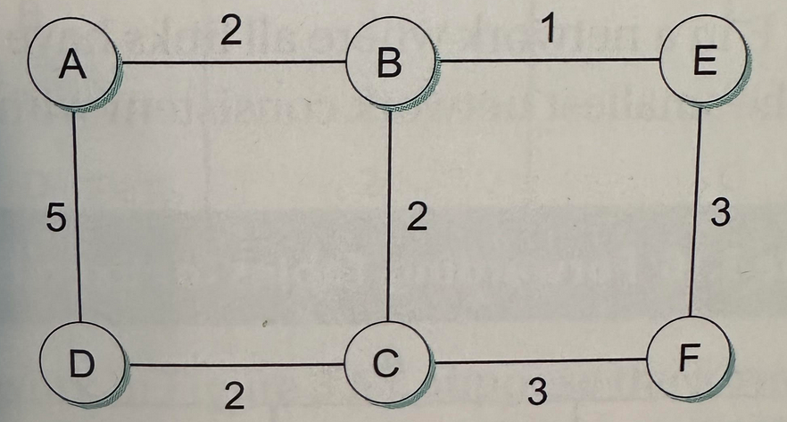

Step 1:
Each node then uses the Dijkstra algorithm to compute a data forwarding table, which includes:
- Destination Node ID.
- Next hop Node ID.
- Metric (cost).
Please print out the forwarding table of each node.
Step 2:
Assume that data packet P1 is sent from node A to node F. Please print the path, detailing the list of nodes that P1 has traversed.

Step 3: Now, suppose the link between nodes B and C is broken. Each node detects this link failure and updates its forwarding table to reflect the change.
Please print out the forwarding table of each node.
Step 4:
Assume that data packet P2 is sent from node A to node F. Please print the path, showing the list of nodes that P2 has traversed.
Deliverables:
Final Report:
- A cover page with the project title and group member names;
- Briefly explain how your project is implemented.
- Screenshots: you may include some screenshots when you run your project;
- Please submit the source program via BlackBoard;
- Note: Each group just needs to submit one Lab report. All students in the same group will receive the same grade

